**COMPUTER ARCHITECTURE AND ORGANIZATION CEN-221**

**LAB-7 (ARITHMETIC INSTRUCTIONS IN MIPS)**

|  |
| --- |
| **Understanding The Concepts Of Register Manipulation** |

**For Different Operations**

**TASK 01:** Write a MIPS assembly language program that takes an input if value is zero or less than zero halt a program else print the number.

**CODE:**

.data

prompt: .asciiz "\n Please Input a value = "

bye: .asciiz "\n **** Have a good day ****"

################### Code segment ###################

.text

.globl main

main:

la $a0, prompt

li $v0, 4

syscall

li $v0, 5

syscall

blez $v0, end

move $a0, $v0

li $v0, 1

syscall

end:

la $a0, bye

li $v0, 4

syscall

li $v0, 10

syscall

**OUTPUT:**

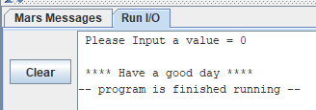

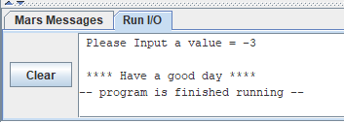

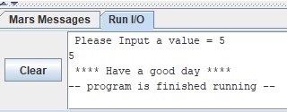

**TASK 2:** Write a MIPS assembly language program that takes an input if the input value is zero only halt a program else print the number.

**CODE:**

.data

prompt: .asciiz "\n Please Input a value = "

bye: .asciiz "\n **** Have a good day ****"

################### Code segment ###################

.text

.globl main

main:

la $a0, prompt

li $v0, 4

syscall

li $v0, 5

syscall

bnez $v0, end

la $a0, bye

li $v0, 4

syscall

li $v0, 10

syscall

end:

move $a0, $v0

li $v0, 1

syscall

la $a0, bye

li $v0, 4

syscall

li $v0, 10

syscall

**OUTPUT:**

